Introduction
Ngunnawal Primary School’s uniform and dress standards meet the requirements of the Education Directorate’s Dress Standards and Uniforms in Canberra Public Schools 2016 Policy. Our uniform was designed with our school community including students, staff and families and was endorsed by the School Board.

Rationale
Our school uniform is a visual representation of the standards expected of students and plays an important role in promoting a positive image of our school. Our uniform aims to support all students to participate fully in school life and help create a sense of identity and a school culture in which every student experiences a sense of belonging. Our school’s uniform ensures all students are easily recognisable as belonging to our school and are dressed safely and appropriately for school activities.
Our school uniform represents our Ngunnawal Primary School community and this document was developed to align with health and safety considerations, anti-discrimination and human rights legislation which protects the rights of students to participate in education safely, actively and equally.
The wearing of school uniforms can also assist to:
- promote a sense of inclusiveness and equal opportunity;
- make school clothing more affordable for families by eliminating the risk of peer pressure to wear transiently fashionable and expensive clothes.

Implementing school uniform requirements
Students attending Ngunnawal Primary School are expected to wear school uniform while travelling to school, at school and attending official school activities.

The School Uniform
We want all students to access the full range of activities at our school and feel comfortable whilst they do so. Our uniform options promote equity and freedom of choice for all students by categorising options by clothing type rather than gender. This empowers all young people, including those who express their identity in diverse ways; to choose from options which meet the uniform standards, without enforcing gendered items that may cause discomfort, anxiety or distress.
Students can choose from the variety of items below.
- Pants - Polo shirts - Dresses
- Shorts - T-shirts - Hats (broad rimmed)
- Skorts - Jackets -
- Skirts - Jumpers

We take pride in our school and our students, so please ensure all items students wear are tidy and in good repair. Items and suppliers have been chosen to ensure affordability, quality and comfort.

Health, Wellbeing and Safety

- Jewellery- To avoid injury, studs or small sleepers are the only ear rings that are acceptable.
- Footwear- Students are required to wear appropriate footwear designed to securely enclose the foot. Sneakers are recommended as they are durable and meet Workplace Health and Safety requirements and allow students to actively participate in school activities. Thongs, ugg boots, ballet flats, sandals and other similar footwear are not appropriate for the school environment.
- Sun Safety- In accordance with the ACT Cancer Society policy, a wide brim hat is necessary. The Cancer Council recommends broad-brim (cricket style), legionnaire and, bucket-style hats. Hats are required for outside activities from August-May each year.
- Dressing for the weather -To maintain health and wellbeing, students are asked to dress appropriately for the weather conditions. A variety of options are available to suit Canberra’s climate.

Special consideration and exemptions

Students who require modification or adjustments to the school uniform due to, health, wellbeing, disability, cultural and/or religious beliefs; are encouraged to meet with the Principal to discuss how we can support you.

The Principal may grant all students a uniform exemption for designated special events such as fundraising uniform-free days and school carnivals. House colours can be worn at whole school events such as athletics or swimming carnivals.

Ngunnawal Primary School is an inclusive school that ensures that students are not disadvantaged due to circumstances beyond their control. If families are experiencing a situation that may present difficulties in accessing school uniforms they are encouraged to speak to the principal. Each unique situation is considered in confidence and the school manages these special circumstances with equity and discretion. Students will have the option of wearing a leadership shirt when they are in year 6. This shirt is unique to this cohort and identifies them as the leaders of the school for their final year of primary school.

When a student isn’t in uniform

The school community has a role to play in encouraging the wearing of our school’s uniform. We ask parents and carers to support this procedure and ensure students are appropriately dressed to participate in school activities. Students will be asked for a note of explanation from parents/ carers if they arrive at school not in uniform.
If students do not meet uniform expectations the following actions may arise:
- Students will be provided an option from the clothing pool to wear;
- Students may not be able to participate in extra-curricular or school activities which are additional to the regular educational program, e.g. excursions, incursions, sports days. Students will not be prevented from participating in curriculum activities, except where necessary for safety reasons. In this instance alternative educational activities will be provided.
- The student’s access to areas of the school such as the playground may be restricted; For example, if a student doesn’t have a hat they may be required to only play in shaded areas.
- Students who are consistently out of uniform will be required to attend a meeting with the Principal to discuss a solution that meets the expectations of the school community. The student's parents or carers will be invited to attend the meeting;
- A process of conflict resolution or mediation will be implemented if a student persistently wears inappropriate dress after discussions have been held with parents or carers.

Purchasing School Uniforms

School uniforms can be purchased directly through local suppliers. Some uniform items can be purchased from a variety of retail stores that sell general school uniform items including Lowes, Big W, K-Mart and Target.

Our uniform shop is operated by the P&C and sells second-hand uniform items. The uniform shop is pleased to accept second hand uniform items in good condition. Refer to the uniform section of the school website or contact the front office for opening hours.

Ngunnawal Primary School ensures that no student is isolated or disadvantaged by not having access to school uniforms and ensure that students wear uniform to foster a sense of belonging and school pride.

Monitoring, Evaluation and review
The Principal is responsible for the development of this procedure and to ensure positive reinforcement of the procedure occurs through regular reminders, for example via the school’s Facebook page, newsletters, information nights and other communication channels.
Any concerns about the application of this procedure or the procedure itself, should be raised with:
- the school Principal in the first instance;
- the Directorate’s Liaison Unit on (02) 6205 5429;
online at http://www.education.act.gov.au/contact_us

Definitions
(as outlined in the Dress Standards and Uniforms in Canberra Public Schools 2016 policy and the Sun (UV) Protection for Students Policy, 2015.)

Dress Standard
A dress standard is a detailed written statement of the expectations that a school board holds regarding student appearance. A dress standard may require students to wear a school uniform and may define specifications for garment design and colour. Alternatively a dress standard may set out broad guidelines as to the appearance of students.

Colour Code
School colour codes are the colours chosen by a school board to represent the school on uniforms and dress standards and other items of identification. In an effort to further establish identity and promote a standard, schools may have two colours or more.

School Uniform
A school uniform consists of a limited range of clothing. It identifies students as belonging to a particular school.

Parents/ carers
Parents/ carers are people with parental responsibility and legal guardians.

Duty of Care
Legal duty of care requires that teachers should take all reasonable measures to ensure safety of a school student under their care. This duty of care will arise whenever a student/teacher relationship exists.

___________________________________________________________________________
Date of Publishing: 2 July 2019

Date for Review: 2 July 2024

Related documents
- Dress Standards and Uniforms in Canberra Public Schools Policy and Procedure
- Dress Standards and Uniforms fact sheet for parents and carers
- Sun UV Protection Policy
- Offering Students Equitable Uniform Options
Related Legislation
Discrimination Act 1991
Disability Discrimination Act 1992
Racial Discrimination Act 1975
Human Rights Act 2004
Work Health and Safety Act 2011

School Uniform and Dress Standards

Ngunnawal Primary School uniform is made up of the school colours navy blue and gold, and encompasses the school logo on shirts, jumpers and jackets.

School Polo Shirt
The school shirt is a gold coloured polo shirt, available in short or long sleeves and has the school logo embroidered on the left side. A polo shirt of the same colour is acceptable. All shirts must be long enough to cover the midriff and have sleeves. Tank tops, singlets and muscle tops are unacceptable.

School Jumper and Jackets
School jumpers, jackets and vests are navy blue. The school jacket and jumper has a school logo embroidered on the left side. A plain or generic version that adheres to the school colour is acceptable.

School Pants, Shorts and Skirts
School pants, shorts and skirts should be navy blue. All shorts and skirts must be at least mid-thigh in length. Short skirts and denim shorts are unacceptable.

School Hat and Headwear
A navy blue broad-brimmed, legionnaires or ‘bucket’ style hat is required to adhere with our school sun protection requirements and our Sun Smart requirements. Hats ordered through our uniform supplier also have a school logo on them. If students wear other headwear this must be in the school colours of navy blue or gold.

Footwear
School shoes and neat covered runners/ sneakers are considered acceptable and safe footwear. Ugg boots, slippers, thongs, crocs, sandals or shoes with heels are not considered to be safe or acceptable footwear and are not to be worn.

Hair and Jewellery
Students with long hair should wear their hair neatly tied back in a pony-tail or plait. This is encouraged to reduce the spread of head lice and to encourage neat presentation. Students who have their ears pierced should wear small, safe earrings to school and all school activities. Students who present with dangly or long earrings will be asked to remove these. This is to ensure that earrings are not a safety risk while at school and to prevent injury.

Ngunnawal School uniform is
Primary Sector P-6 | 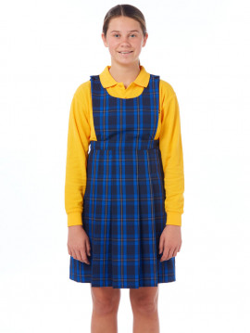  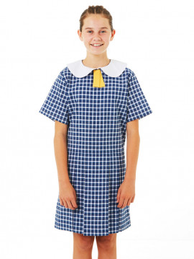  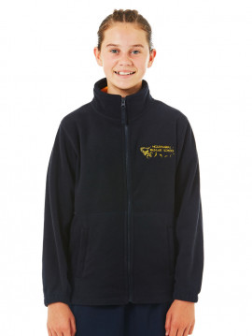  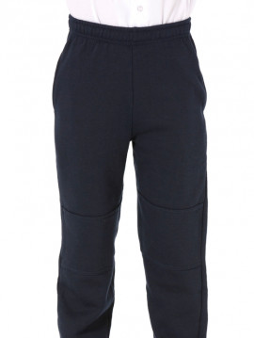  Zip polar fleece jumper  Winter Tunic  Summer Dress  Navy track pants  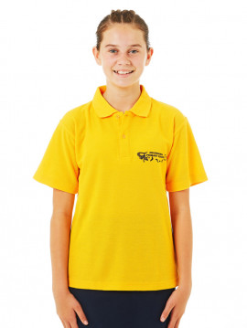  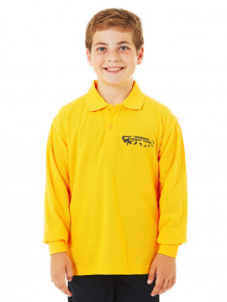  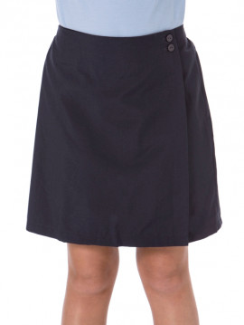  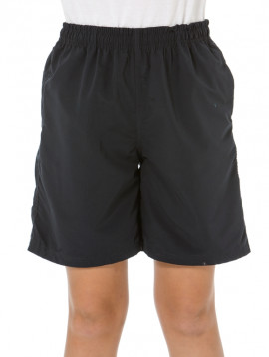  Navy Skort  Navy Shorts  L/S Gold polo shirt  S/S Gold polo shirt

