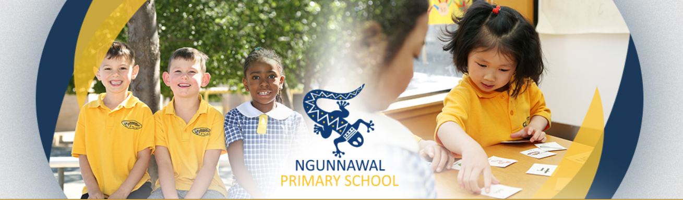

Ngunnawal Primary School

Wellbeing Framework


Contents
RATIONALE

UNIVERSAL PRACTICES
- Bounce Back
- Protective Behaviours
- Zones of Regulation
- Positive Behaviours for Learning
- Sequence of Universal Programs Preschool to Year 6

SELECTED AND TARGETED ADJUSTMENTS TO SUPPORT STUDENTS TO BE SUCCESSFUL
- Tiered instructions
- The Reflection Room
- Restorative Practices
- Transitions
- Inclusion Referral Process
- EAL/D Program
- Gifted and Talented
- Support at Preschool
- Inclusion Support Program
- Disability Education Program (LSU)
- Network Student Engagement Support (NSET)
- Occupational Violence Team

The National Disability Insurance Scheme (NDIS) and School Education
- Targeted Programs: Secret Agent Society

SERVICE PROVISION
- School Psychologist
- Early Years Engagement Partner
- Salvation Army Mentoring
- ACT Volunteer Program

PLANNING FOR SUPPORTING STUDENTS
- Adjustment Matrix
- Personalised (P) Programs
- Individual Learning Plans (ILPS)
- Safety Plans

RESPONSE TO BULLYING
- Procedures
- Definitions

ONLINE SAFETY
- eSafety Resources

Rationale
The Australian Student Wellbeing Framework affirms children’s rights to education, safety and wellbeing under the United Nations Convention on the Rights of the Child.
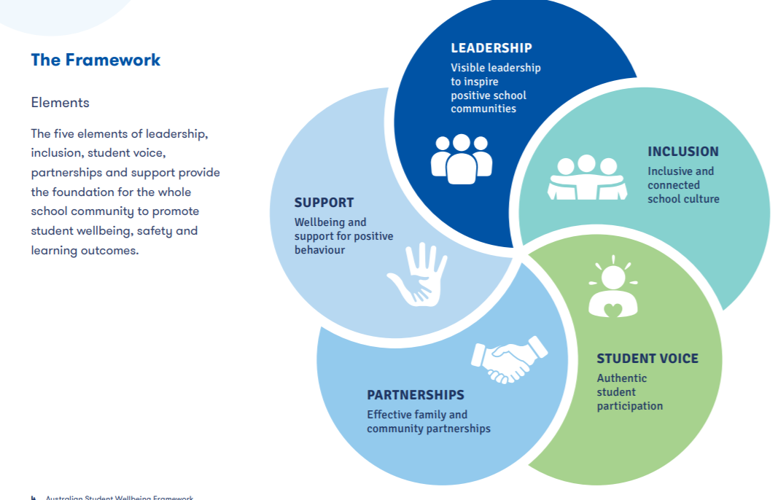
The framework supports Australian schools to provide every student with the strongest foundation possible for them to reach their aspirations in learning and in life.​
Similarly, teachers, parents and other local community members have the right to feel safe, supported and respected in the school context.
ACT Education Directorate Policies have a strong interconnection between student safety, student wellbeing and learning. Effective student learning and wellbeing is promoted through a safe and inclusive school climate in which students, families and staff feel a sense of belonging. Our school approach is informed by the ACT Education Directorate Safe and Supportive Schools Policy.
The Safe and Supportive Schools policy states:
- Canberra public schools are committed to providing positive and engaging environments where young people feel connected and respected, achieve success and are fully engaged in education. Student wellbeing impacts on student learning and is fundamental to a student’s successful engagement with education.
- This policy provides guidance for Canberra public schools on promoting a safe, respectful and supportive school community

http://www.det.act.gov.au/publications_and_policies/policy_a-z.
https://www.studentwellbeinghub.edu.au/docs/default-source/aswf_booklet-pdf.pdf

Universal Practices
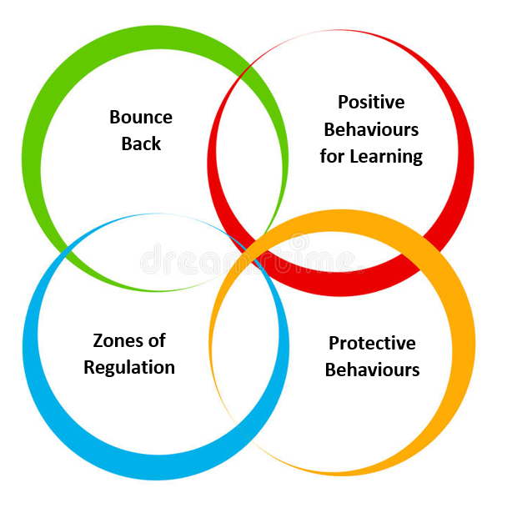
Bounce Back
Bounce Back is a fully integrated whole school social and emotional learning curriculum program promoting sustainable mental health, wellbeing and resilience for students and teachers. It provides practical strategies to improve student wellbeing and help students (and teachers) cope with the complexity of their everyday lives. It teaches them how to ‘bounce back’ when they experience sadness, difficulties, frustrations and challenging times. Bounce Back is an evidence-informed program built on Positive Psychology, Cognitive Behaviour Therapy and Social and Emotional Learning principals.

At Ngunnawal Primary School Bounce Back is taught from Kindergarten to Year 6. There are ten curriculum units each scoped and sequenced across K-2, 3-4 and 5-6, building and deepening knowledge and skills from year to year. Students will engage in a weekly lesson (30-60mins).

Protective Behaviours
Protective Behaviours is a training program which assists children, adolescents and adults to deal with unsafe situations. The program addresses issues of abuse – physical, sexual, emotional and neglect – in a sensitive manner. It teaches strategies which assist in the primary prevention of abuse. It assists children who have already been abused or are at risk o abuse to access the help they need. The Protective Behaviours Program also provides a basis for addressing issues such as bullying and harassment, domestic violence, racism and sexism.
Protective Behaviours is based on the two themes:
“We all have the right to feel safe all the time.”
And
“Nothing is so awful that we can’t talk about it with someone.”
These themes are developed so that each child recognises his or her own right to feel safe; and develops an individually chosen network of adults who will listen, believe and help take some action so that the child feels safe again.
At Ngunnawal Primary School, the Protective Behaviours program is delivered as a short unit at the start of each alternate school year.

The Zones of Regulation
The Zones of Regulation® is a framework and easy-to-use curriculum for teaching students’ strategies for emotional and sensory self-management. Rooted in cognitive behavioural therapy, The Zones approach uses four colours to help students identify how they are feeling in the moment given their emotions and level of alertness as well as guide them to strategies to support regulation. By understanding how to notice their body’s signals, detect triggers, read social context and consider how their behaviour impact those around them, students learn improved emotional control, sensory regulation, self-awareness, and problem-solving abilities.

Using a cognitive behavioural approach, the curriculum’s learning activities are designed to help students recognise when they are in different states or “zones,” with each of four zones represented by a different colour:

The Red Zone is used to describe extremely heightened states of alertness and intense emotions. A person may be elated, euphoric, or experiencing anger, rage, explosive behaviour, devastation, or terror when in the Red Zone.

The Yellow Zone is also used to describe a heightened state of alertness and elevated emotions, however individuals have more control when they are in the Yellow Zone. A person may be experiencing stress, frustration, anxiety, excitement, silliness, the wiggles, or nervousness when in the Yellow Zone.

The Green Zone is used to describe a calm state of alertness. A person may be described as happy, focused, content, or ready to learn when in the Green Zone. This is the zone where optimal learning occurs.

The Blue Zone is used to describe low states of alertness and down feelings such as when one feels sad, tired, sick, or bored.

At Ngunnawal Primary School, the Zones of Regulation language and strategies will be taught at a universal level during the emotions unit in the Bounce Back program. The strategies/resources will then be used specifically to support Tier 2 and 3 students to regulate and self-manage emotions as needed.

Positive Behaviours for Learning
Positive Behaviour for Learning, known as PBL is an evidence based whole school systems approach. At Ngunnawal Primary this looks like:

- Consistent behaviour expectations created in consultation with all stakeholders including students, staff and community members
- Consistent language and approaches to support positive behaviour choices
- Explicit lessons used to teach behaviour expectations with opportunities to practise appropriate behaviours in classroom and on the playground

PBL Whole School Expectations
Our S.H.A.R.E values will overarch our Ngunnawal Primary PBL vision.
Our whole school expectations are:
- We are Safe
- We are Respectful
- We are Responsible Learners

Positive Acknowledgment
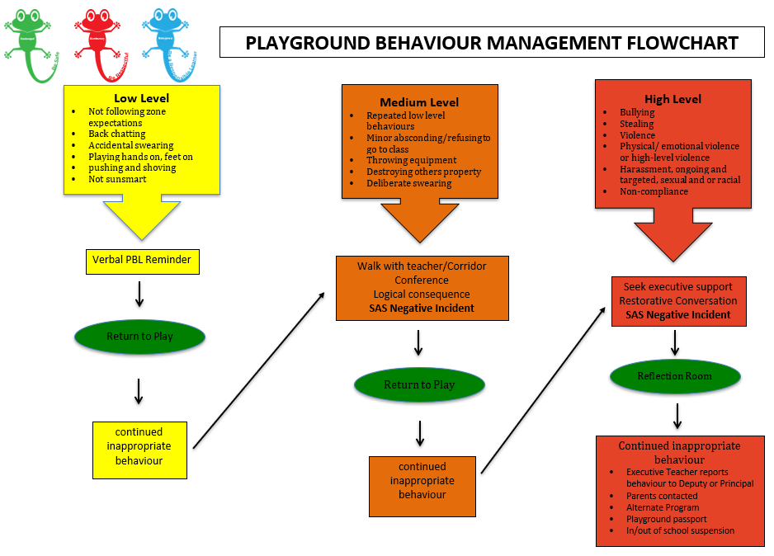
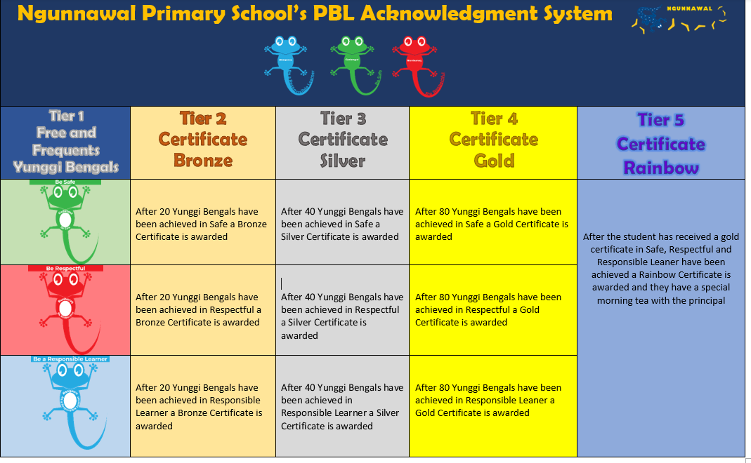

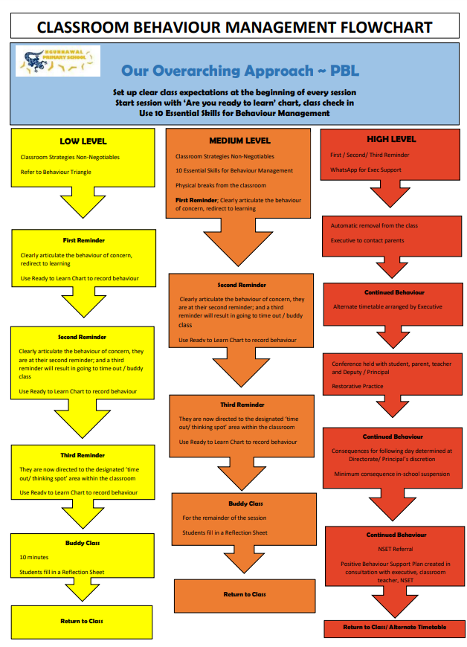

Sequence of Universal Programs Preschool to Year 6

 |  | Term 1 | Term 2 | Term 3 | Term 4
A Year | P | PBL class expectations  Zones of Regulation | PBL all settings  Zones of Regulation | PBL other areas  Protective Behaviours | Protective Behaviours
A Year | Kindy | PBL class expectations  Zones of Regulation | PBL all settings  Zones of Regulation  Unit 3 – People bouncing back | PBL other areas  Unit 7 - Relationships  Unit 9 – Being safe | Unit 6 – Emotions  Unit 10 – Success
A Year | 1-6 | PBL class expectations  Zones of Regulation | PBL all settings  Zones of Regulation  Unit 3 – People bouncing back | PBL other areas  Unit 1 – Core values  Unit 2 – Social values | Unit 4 – Courage  Unit 6 - Emotions
B Year | P | PBL class expectations  Zones of Regulation | PBL all settings  Zones of Regulation | PBL other areas  Protective Behaviour | Protective Behaviours
B Year | Kindy | PBL class expectations  Protective Behaviours | PBL all settings  Protective Behaviours  Unit 3 – People bouncing back | PBL other areas  Unit 7 - Relationships  Unit 9 – Being safe | Unit 6 – Emotions  Unit 10 – Success
B Year | 1-6 | PBL class expectations  Protective Behaviours | PBL all settings  Protective Behaviours  Unit 7 – Relationships | PBL other areas  Unit 5 – Looking on the bright side  Unit 8 – Humour | Unit 9 – Being safe  Unit 10 - Success

Service Provision
Ngunnawal Primary School is committed to effectively supporting all students in our school, actively engaging with parents and carers to provide inclusive, accessible and high-quality education for all students.
All schools are required to make reasonable adjustments ensuring they have the support they need to successfully access and participate in the school curriculum, programs and activities on the same basis as their peers.

Our school will:
- consult with parents and carers to understand their child's education needs and the adjustments required to support the student
- make the reasonable adjustments that are necessary to enable a student with a disability to take part in education on the same basis as other students
- assist students and families to feel safe and supported in the education environment.

School Psychologist
Our School Physiologist works with students, parents or carers and teachers in a variety of ways to help support our students and families. Their work includes:
- direct support or interventions to students
- consult with teachers and families
- work alongside others to assist students to thrive in their school environment.
- work with the school executive team on school-wide practices and procedures
- collaborate with community providers to co-ordinate services for students

Early Years Engagement Partner
Partnership and collaboration are central to children reaching their full potential in the early years. Building strong partnerships achieve the best long-term outcomes for children as it fosters learning and provides holistic development. At Ngunnawal Primary School, our Early Years Engagement Partner fosters strong partnerships with families to achieve the best educational outcomes for their children.

Their work includes:
- Coordinating quality services for children and their family
- Supporting stakeholders in strengthening their understanding of the diverse and complex learning and development needs of young children
- Developing and implementing a suite of early years interventions and supports
- Problem-solving and planning collaboratively across the school and community services in case meetings, professional learning and team meetings

Salvation Army Mentoring
The Salvation Army School and Community Program provides opportunity for students who are struggling or discouraged to be supported in their learning through individual or small group (1 to 3 children) mentoring.

The most frequent needs catered for are:
- Anxiety
- Weak or behind in specific subject matter
- Other personal or social needs

The program includes:
- Providing a listening ear and respectfulness
- Assistance in supporting and developing literacy and numeracy skills
- Developing social and interpersonal skills with relevant activities, games and positive role-modelling

ACT Volunteer Program
The ‘School Volunteer Program ACT’ provide enrichment opportunities that enhance the education experience for students, while supporting teachers and staff. Trained mentors work with children and young people to increase their engagement in learning and build self-confidence. Students are selected by teachers; some may be struggling readers or lacking in confidence with number, others may be very able but require extra challenges to maintain interest and engagement. Mentors bring a wealth of knowledge and experience from both their professional, and family lives. They provide opportunities for intergenerational learning. Mentors have an appreciation for and make a commitment to mentoring children and young people. ‘School Volunteer Program ACT’ link students with the wider community and provides them with mature role models, demonstrating what it is to be a caring member of society.

Selected and Targeted Adjustments to Support Students to be Successful

Tiered instruction
A multi-tier approach is used to efficiently differentiate instruction for all students. The model incorporates increasing intensities of instruction offering specific, research-based interventions matched to student needs. Students not making adequate progress in the regular classroom (Tier 1) are provided with increasingly intensive instruction (Tier 2) matched to their needs on the basis of levels of performance and rates of progress. Intensity varies across group size, frequency and duration of intervention. These services and interventions are provided in small-group settings in addition to instruction in the general curriculum.

The Reflection Room
The reflection room is a space for students to attend who have demonstrated unsafe behaviour on the playground. This space provides students with the opportunity to reflect on their actions and behaviours independently and then discuss them with a teacher and identify how their behaviour can be changed to ensure they are being safe and respectful.

The reflection room is run at lunch time in the wet area of Gundaroo with an Executive Teacher. Students who attend are to arrive straight after eating time. The session runs for 15 minutes.

The reflection room logbook (google doc) needs to be completed prior to the student attending. This will align with our SAS reporting protocols and all incidents being entered into the logbook require a SAS incident number. The reporting teacher is the teacher who witnessed the behaviour on the playground.
Reflection is an important practice which allows our students to learn from their actions and grow.
Executive teachers will have discussions with students about the school expectations and how their playground behaviours affect others. The focus is on how the behaviour/action could be changed and what could have been done instead so that the situation has a positive outcome. As a follow-up to these discussions teachers explicitly discuss strategies students could use if they get into a similar situation again.

Subsequent visits will see the students having further discussions with the executive teacher about their action on the playground, this could result in further activities exploring options to support their behaviour during conflict. If a student visits the reflection room more than 3 times the executive teacher will contact their parents to discuss this ongoing behaviour. This will also be logged in the reflection room logbook and the student’s teacher will be notified.

Restorative Practice
Restorative practices promotes inclusiveness, relationship-building and problem-solving, through such restorative methods as circle time for teaching and conflict resolution to conferences that bring victims, offenders and their supporters together to address wrongdoing. Instead of punitive measures such as detention and suspension which aggravate issues such as bullying, violence, poor academic performance and parental apathy, restorative practices encourage students to reflect on and take responsibility for their actions and come up with plans to repair harm. Restorative approaches can transform student behaviour and build healthy school communities. At Ngunnawal Primary School, teachers use RP questions to help guide conversations when issues arise between students.

Transitions
Points of transition are critical times for children and young people and their families and need to be managed sensitively and effectively to ensure continuity. Significant transitions occur at natural transition points such as the move to preschool, primary school, high school and college; between schools or education sectors and from schooling to adult life. Even the move from one teacher to another or from one class to another can pose significant challenges for some students. A Transition Action Plan (TAP) is used to support students with disability and their families to transition from one setting to another. Transition goals should also be included in student ILPs.

Inclusion Referral Process
Ngunnawal Primary School recognises that all students progress at their own pace, at times teachers and families may raise concerns or considerations about a child’s academic or social/emotional progress. School leaders, the school psychologist, engagement partner and the teacher discuss the individual student need/s through a referral process resulting in a team approach to ensure actions and outcomes arising from the process are carried out in a timely manner to best serve the student and the family.

English as Additional Language/Dialect (EAL/D)
English as an Additional Language or Dialect (EAL/D) is the study of English by students whose first language is a language or dialect other than English, and who require focused educational support to assist them in attaining proficiency in Standard Australian English.

Gifted and Talented
Students identified as gifted or highly capable through subjective and objective measures may be clustered within a class. These groups are designed to broaden students’ understandings of concepts and skills through differentiated curricula. Opportunities exist for students with subject specific capabilities, e.g. in mathematics, to be regrouped for further extension during the year. Other adjustments for students include:

- Acceleration  - Grade skipping  - Subject acceleration  - Curriculum compacting  - Full time ability grouping  - Advanced classes in specific areas  - Cluster grouping  - Multi-grade classes | - Encouragement to enter competitions e.g. Mathematics Challenge and International Competitions and Assessments for Schools (ICAS) among others  - Encouragement to enter talent workshops.

Support at Preschool (SAP)
Support at Preschool (SAP) is a referral process whereby schools can seek observation and advice to make adjustments required to support the inclusion of children with disability or developmental delay. SAP teachers work to develop the understanding and skills of all staff within a preschool setting to support children with delays in their development or with disabilities to participate fully in the preschool group. Support at Preschool can also allocate financial resourcing to schools to allow for additional staff to cater for a child’s need and support positive participation in preschool.

Inclusion Support Program (ISP)
Parents requesting ISP support enrol their child directly through the online enrolment process and the school that offers the child’s enrolment will receive the ISP resourcing to cater for the child’s level of need. Entry into ISP may occur throughout the child’s school years and involves consultation with school staff, school psychologist and often external medical professionals. A Student Centered Appraisal of Need (SCAN) meeting is organised as a result of entry into the ISP and all stakeholders are involved in this process. ISP funding is allocated as a result of the SCAN meeting outcomes and the school receives ISP resourcing. An Individual Learning Plan (ILP) with targeted goals is created at the SCAN meeting, the ILP determines the prioritised learning for the individual. These goals may be within the developmental domains or specific to a curriculum area. Funding is provided in the way of Learning Support Assistant time with the student in their mainstream class setting or in an alternate program as determined by the student’s need and their Individual Learning Plan.
Disability Program: Learning Support Units (LSU)
LSUs are small group classroom settings catering to a range of complex student. Students may meet the ACT Student Disability Criteria for Intellectual Disability, Autism or it is determined by the school in consultation with families/carers that this setting would best support an individual student’s learning needs.
Ngunnawal Primary School provides a range of flexible programs and supports to meet the needs of students eligible to access LSUs from the time of their enrolment through to Year 6.

School teams, including the school psychologist, work with parents and carers to understand and support the student’s educational needs and the interventions necessary to support their learning and engagement. The school psychologist will support parents to consider the range of programs and supports the student is eligible for.

Network Student Engagement Team (NSET)
The ACT Education Directorate provides a range of support for schools and their students. One of these supports is the Network Student Engagement Team (NSET). The purpose of each NSET is to provide additional support so that schools can best support their students who are facing a range of challenges, to engage/participate in their learning and achieve their educational potential. This may include developing a Positive Behaviour Support Plan (PBSP), Protective Action Plan (PAP) or an Absconding Plan.

Occupational Violence Support Team
The OV team works collaboratively with schools to assess the risk students may present in the workplace. This process assists schools to develop strategies to manage occupational violence.

The National Disability Insurance Scheme (NDIS) and School Education
The NDIS is a new way of supporting people with disability and can include funding for individual supports. The NDIS is administered by the National Disability Insurance Agency (NDIA). For information about the NDIS and school education:
The National Disability Insurance Scheme (NDIS)
Targeted Programs: Secret Agent Society
Secret Agent Society (SAS) Small Group Program is an evidence-based, multimedia program to help children improve their social and emotional resilience. This breakthrough social skills approach is used with 8 to 12-year-old children with a range of social and emotional challenges.

- High functioning Autism / Asperger’s
- Anxiety Disorders
- Attention Deficit Hyperactivity Disorder (ADHD)
- Anger management difficulties
- Other general challenges with friendships, team work, conversations or staying calm

Planning for Learning Adjustments

Adjustment Matrix
The Adjustment Matrix supports schools to identify personalised adjustments required for a student to access, participate and achieve in learning.

Individual Learning Plan (ILP)
An Individual Learning Plan is a working document, designed by teachers in collaboration with stakeholders, which informs the planning, delivery and evaluation of an educational program.

An Individual Learning Plan
- is a teaching tool used to deliver a targeted educational program to achieve
- outlines appropriate learning outcomes for identified students with specific needs
- is developed through a collaborative planning process involving the school, parents/carers and external agencies
- it identifies the student’s individual needs and priorities for learning both short and/or long term educational goals, actions, strategies, modifications and adaptations that will be taken to achieve them
- It identifies the grade level standard at which the student is currently working within/or towards (reported)
- is a flexible living document that is reviewed and modified over time
- assigns responsibility and accountability for implementing and evaluating the plan
- provides an ongoing record to ensure continuity of learning.

ILP goals are drawn from four key areas, communication and social needs, living skills/personal care, motor skills, cognitive needs and possibly transition needs.

Personalised (P) programs
Students with additional learning needs at Ngunnawal Primary School have a Personalised (P) Program. The ‘P’ identifier is used for any student on an ILP where a student is operating above or below their academic year level Achievement Standard, and where a significant amount of their intended learning is drawn from Achievement Standards above or below their current year level. Achievement Standards may be drawn from one or more different year levels per learning area. Please note that the P identifier does not relate to students who have been accelerated.

This is an individually adjusted learning program that is documented through an ILP. The ILP is developed in consultation with parents, and other appropriate people to establish the learning goals for the child each year. Class teachers adapt the Australian Curriculum to suit the learning needs of individual student and their academic report reflects the academic standard that they are working at.

Safety Plan
School developed plan identifying appropriate, minor and major behaviours specific to the student, key personnel and strategies to promote positive behaviours.

Responding to Bullying
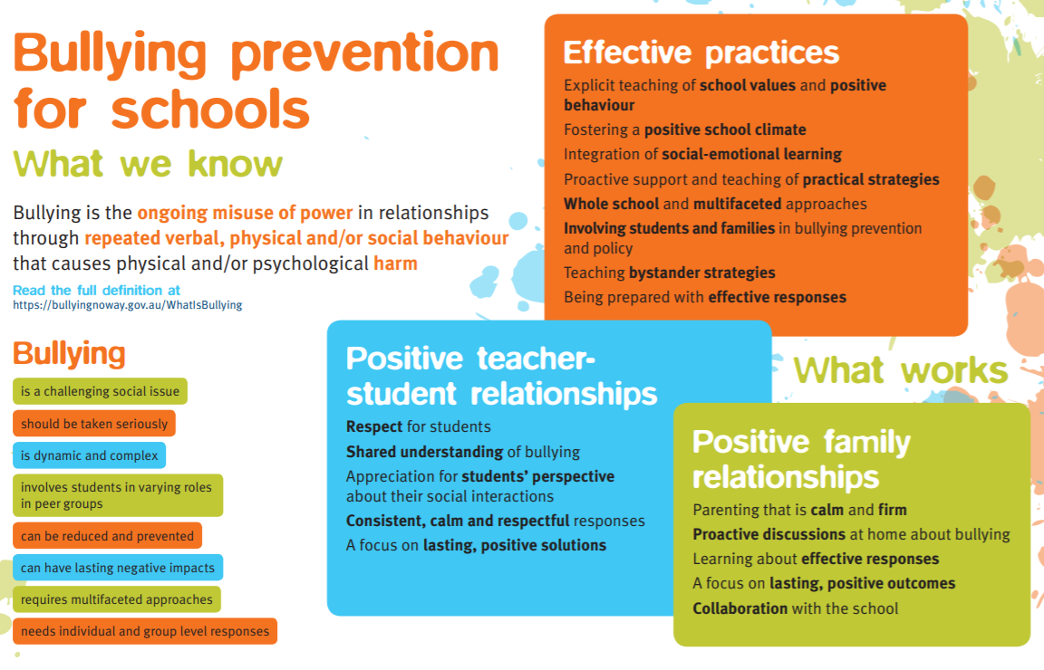

Bullying: an ongoing misuse of power in relationships through repeated verbal, physical and/or social behaviour that causes physical and/or psychological harm. It can involve an individual or a group misusing their power over one or more persons. Bullying can happen in person or online, and it can be obvious (overt) or hidden (covert). Bullying of any form or for any reason can have long-term effects on those involved including bystanders.

Cyber bullying: Bullying that occurs through social media and/or telecommunications platforms.

Single incidents and conflict or fights between equals, whether in person or online, are not defined as bullying.

Procedures for reporting bullying
It is important that our school community is proactive in dealing with bullying and harassment, so we encourage incidents to be reported.

- Students can talk to any teacher or member of staff
- Parents can email teachers or executive staff to report bullying or request an appointment
- Staff can contact the Respect, Equity and Diversity Contact Officer (REDCO)

Procedures for responding to bullying
We encourage students and staff to report bullying and harassment (including physical, verbal, sexual, racial, homophobic, transphobic, social and cyber) and we address incidents on an individual basis. This may include evaluating:
- the severity of the incident
- the repetition of the incident
- the impact of the incident on self and others

Investigating the incident
Information will be collected from all perspectives including written statements from students involved and any bystanders.

Immediate support and ongoing management for all students involved:

- The incident to be discussed with an executive staff member and make a plan of actions.

- Ensure everybody has a thorough understanding of the incident and the role of those involved.

- Record the event details in Sentral for all students involved.

- Liaise with families/parents (meetings may be required).

- Develop an appropriate intervention plan. This might include:

a) inclusion referral for school care team discussion
b) School Psychologist intervention
d) alternative programs/external agencies
e) disciplinary action (e.g. playground passports, reflection room, restraint from harassment agreements, suspensions, police involvement etc)
f) restorative conversations between students

- Keep open and ongoing communication with relevant staff and families.

- Implement the plan and review it.

School strategies​
School staff understand that it can be distressing for a parent or carer to find out their child has been bullied. They will try to support you and your child as much as possible and include you in discussions about strategies that could be used.

The school will consider your child's circumstances and will select the most appropriate strategies.
These strategies could include:
- teaching and learning programs to develop student’s communication, social, assertiveness and coping skills
- changes to the school environment to improve teacher supervision, such as removing visual barriers between teacher and students
- increasing supervision of students at particular times or places
- support from a guidance officer or school counsellor
- changes to technology access at school
- timetable or class changes that may be temporary or permanent to decrease the contact the students have with each other
- class discussions of bullying including underlying issues and possible responses for students
- promoting positive bystander behaviour
- disciplinary action against students who bully others.

If further incidence of the bullying cycle occurs:
- Appropriate person, in collaboration with the principal, to interview student and their parents or carers
- Principal to make clear consequences of repeat occurrence
- Further action (internal/external suspension) is at the discretion of the principal
- Appropriate person to counsel victim and be in contact with family

Privacy
Schools must follow privacy laws and may not be able to tell you everything that has taken place, especially about any other children involved. These laws also serve to keep your child's information private.

Less Effective Strategies to Avoid
There are many beliefs about bullying and ways of dealing with behaviour that have been shown, through research, to be far less effective than whole-school positive behaviour su​pport approaches. These include:
- zero tolerance and 'get tough' suspensions and exclusions
- rigid control of student behaviour
- belief that students must receive punitive and negative consequences in all cases
- increased security measures
- unfair and inconsistent use of discipline
- punishment without support

Definitions

Bullying: an ongoing misuse of power in relationships through repeated verbal, physical and/or social behaviour that causes physical and/or psychological harm. It can involve an individual or a group misusing their power over one or more persons. Bullying can happen in person or online, and it can be obvious (overt) or hidden (covert). Bullying of any form or for any reason can have long-term effects on those involved including bystanders. Single incidents and conflict or fights between equals, whether in person or online, are not defined as bullying.

Cyberbullying: Bullying that occurs through social media and/or telecommunications platforms.

Diversity: is about recognising the value of individual differences to school culture. Diversity can include sex, gender identity, sexual orientation, language, ethnicity, cultural background, age, religious belief, family makeup and family responsibilities. Diversity also refers to other ways in which people are different, such as educational level, life experience, work experience, socio-economic background, personality, marital status and abilities/disabilities. Diversity is more than merely accepting people from diverse backgrounds – it is about active support and celebration of difference.

Duty of care: the responsibility to exercise reasonable care to protect the safety of any students against injury that should reasonably have been foreseen. This duty exists whenever a student/teacher relationship exists, while students are on school premises during hours when the school is open and while on school-based activities taking place elsewhere.

Positive Behaviour Support Plans: are evidence-based plans, based on a functional behavioural analysis of the purpose of the behaviour in the context of the student’s environment. They outline proactive strategies that build on the person’s strengths and support the learning of positive replacement behaviours and skills. A Positive Behaviour Support Plan is the primary planning tool for bringing about positive behaviour change for a student.

Protective Action: describes the interventions taken by staff to minimise the risk when a significant danger is present. This might include restrictive practices, non-physical interventions and changes to the immediate environment. The danger may be from the actions of a person or from hazards in the immediate environment.

A Protective Action Plan: refers to a plan that guides immediate response strategies for the management of aggressive, violent and unsafe behaviours of a particular student that are presenting imminent risk of harm to the individual or others. These strategies are only used when all other planned responses have failed. It is informed by a deep knowledge of the individual student’s circumstances. The Protective Action Plan will always have an accompanying Positive Behaviour Support Plan.

Respectful relationships: are interpersonal interactions where all parties feel safe, are treated with fairness, are valued and feel accepted. This concept applies to all relationships, including friendships, student-student, student-teacher, teacher-family, family and partner relationships.

Restorative Practices: are strategies that seek to repair relationships that have been damaged, including those damaged through bullying. It aims to do this by bringing about a sense of remorse and restorative action on the part of the wrongdoer and forgiveness by the victim. The restorative approach, reintegrates wrongdoers back into their community and reduces the likelihood that they will continue to misbehave.

Restrictive Practice: is defined as any practice or intervention that has the effect of restricting the liberty or freedom of movement of a person, with the primary purpose of protecting the person or others from harm. Restrictive practices must only ever be used as a last resort option to prevent harm to the individual or others. They should only be used within the context of a positive behaviour support approach, and only after all other less restrictive options have been applied or are not practicable in the circumstances. They must not be used to gain compliance in students. Refer to Safe and Supportive Schools Policy Procedure B. Restrictive Practices include:

Restraint is the use of force to subdue or restrict a person’s movement. It can be mechanical (using an object) or physical, using a part of a person’s body.

Seclusion is the sole confinement of a person in a room or place where the doors and window cannot be opened by the person.

Social and Emotional Learning (SEL): is the process through which students acquire and effectively apply the knowledge, attitudes, and skills necessary to understand and manage their emotions, set and achieve positive goals, understand and show empathy for others, establish and maintain positive respectful relationships, and make responsible decisions.

Student Wellbeing: is defined as a state of positive psychological functioning that allows students to thrive, flourish and engage positively with their school and other people.

Violence: is the use of force, threatened or actual, against another person(s) that results in actual or apprehended physical harm or property damage. Violence may involve provoked or unprovoked acts, multiple incidents, or a pattern of behaviour which creates a context for separate incidents. It may involve a random or a deliberate act. Threatened or actual conduct involving weapons or implements used as weapons is considered to be a serious act of violence.

Source: https://bullyingnoway.gov.au/

Online Safety
Online eSafety Resources for Families of Young People

The Office of the eSafety Commissioner provides advice and support to all Australians in understanding how to be safe in the online world. To support your young person to navigate their digital world and avoid harmful online experiences, the following information can assist you in having the hard-to-have conversations about online safety and setting boundaries.

Your support and guidance can give your young person the confidence to make sound decisions online – and know where to go for help when they need support or advice.

Be engaged, open and supportive

• Get involved. Share online time with your young person as a part of family life. Talk about favourite apps, games, and websites.

• Keep lines of communication open. Ask about their online experiences, who they are talking to and whether they are having any issues.

• Reassure your young person they can always come to you, no matter what. Let them know you will not cut off internet access if they report feeling uncomfortable or unsafe when online – this is a real concern that may stop your child from communicating with you openly.

• Get to know the devices you and your young person use and set them up for privacy and online safety.

• Use parental controls as appropriate to set boundaries.

• If you feel your young person needs support, please maintain contact with your school so you can work together to support them. Seek professional help if your young person is distressed or shows marked changes in behaviour or mood, remembering that organisations such as Kids’ Helpline and Beyond Blue can help.

• If you feel your young person is in immediate danger or at risk of harm, call Triple Zero (000) and stay with them until they are safe.

You can find additional information and resources at the Office of the eSafety Commissioner to support you and your young person.

